Stock Market Prediction using Deep Learning
and ML

Shah Mustaim Anik
American International
University-Bangladesh
Dhaka, Bangladesh
22-47127-1@student.aiub.edu

Md. Faysal Mahmud Fahim
American International
University-Bangladesh
Dhaka, Bangladesh
22-46912-1@student.aiub.edu

Nawshin Anjum Prima
American International
University-Bangladesh
Dhaka, Bangladesh
22-48839-3@student.aiub.edu

Abstract—Nowadays stock market prediction is a challenging task because stock prices are nonlinear and affected by many internal and external factors. Traditional forecasting methods often fail to detect financial time series data which also affects prediction accuracy. This research proposes a Long Short-Term Memory (LSTM) based stock market prediction model using historical sock data collected from Kaggle dataset containing 8000 CSV files. Each CSV file contains the trading history of an individual stock. The model was trained to predict the next day’s closing stock price using different sequence lengths. Performance was evaluated using MAE, EMSE, and R² score. Experimental results showed that 60-day sequence length produced batter prediction performance. This indicates that LSTM can effectively learn time series patterns from historical stock data and provide excellent results for price forecasting. However the study has limitations because it only used historical numerical data and does not include external factors.
Keywords— Stock market prediction, LSTM, Time series forecasting, Financial forecasting.

Introduction
Stock prices are highly dynamic, and nonlinear. That’s why stock market prediction has become one of the major research areas in the fields of finance and machine learning. Proper prediction of the stock market can assist the investors, financial analysts, and organizations in making better investment decisions, that can minimize financial risks. Financial time-series data are highly complex, these are difficult to capture using traditional forecasting methods like statistical analysis, moving averages, and regression models [1]. The stock market prediction has drawn attention to the machine learning and deep learning approaches with the development of AI and Data mining technologies. To achieve better prediction accuracy, different prediction algorithms like Artificial Neural Network (ANN), Support Vector Machine (SVM), Random Forests and Recurrent Neural Networks (RNN) have been applied to the research.
Accurately predicting stock market is difficult because stock prices are highly nonlinear and influenced by multiple factors. Traditional forecasting methods and conventional machine learning models often fail to capture financial time-series data. It often leads to reduce prediction performance. To solve this problem an LSTM-based stock market prediction system needed to be developed. Which is capable of learning long-term dependencies from time series stock data to provide more accurate future stock price predictions.
The LSTM networks have a unique feature compared to CNN. LSTM have memory cells that store important information for long durations and gating mechanisms, which makes them suited for time-series forecasting [4]. LSTM models are superior to traditional machine learning and statistical methods in forecasting stock prices and market trends through several studies [5] and [6]. Researchers have also tried to improve the performance of LSTM by teaching technical indicators, sentiment analysis and attention mechanisms to prediction frameworks [7] and [8] as a result, this research aims to create a stock market prediction system based on historical stock market data to predict future stock prices using the LSTM deep learning model, which would provide improved accuracy.

Literature Review
The prediction of stocks is a hot topic in the research world due to the volatility, nonlinearity and uncertainty of these markets. Traditional statistical methods such as ARIMA, moving average, linear regression are not sufficient to model the stock prices and in recent years machine learning and deep learning techniques, such as neural networks, have been encouraged [1, 2]. Using Algorithms to improve forecasting accuracy, such as Artificial Neural Networks (ANN), Support Vector Machines (SVM), Random Forests, Recurrent Neural Networks (RNN) and Long Short-Term Memory (LSTM) models have been adopted [3, 4]. In [2] the authors, Moghar and Hamiche, showed that LSTM networks can outperform traditional forecasting models by learning the long-term temporal dependencies found in the stock market data. Similarly, Sidhu et al., Pramod and Shastry have developed the LSTM models to predict the stocks and proved that LSTM-based forecasting model is more accurate in comparison to traditional models [10, 14]. Ghosh et al. used the LSTM models on the Indian stock market and showed the ability of deep learning methods in exploring hidden temporal patterns from historical data of stocks [13]. Maikatsina et al., Gautam et al., and Xiao et al. conducted comparative studies which revealed that the LSTM models outperformed SVM, Random forest, GRU, Transformer and ARIMA models as it is effective in handling the nonlinear sequential data [7, 8, 9]. Mehtab et al. also proposed hybrid machine learning and LSTM-based architecture for walk-forward forecasting that deliver high forecasting accuracy for Nifty 50 stock index, [15].

The recent studies focus primarily on the enhancement of predictive capability of the stock market using sentiment analysis, technical indicators, attention mechanisms and hybrid forecasting models. Ouf et al. employed public opinion, LSTM and XGBoost classifiers as well as Twitter sentiment analysis to improve prediction performance [3]. The combination of news articles and on-line forum discussions with LSTM networks and sentiment analysis with BERT led to an improvement of approximately 12.05% in the accuracy of RMSE [5]. Zakka and Emigawaty presented an RLSM (Recursive LSTM) forecasting model which uses the technical indicators, such as RSI, EMA, MACD and Bollinger Bands for stable multi-step prediction [4]. So Sang and Li proposed the attention-based LSTM (AMV-LSTM) to solve overfitting and instability problem of the normal LSTM network [6] for the same reason. On the other hand, Li et al. suggested an attention-based multi-input LSTM network which is able to selectively filter out irrelevant features and further improve the prediction accuracy of multiple correlated stock factors [11]. Bhatia and Bhatt compared LSTM and GRU based forecasting methods with traditional methods of time-series forecasting and concluded that LSTM and GRU can perform better than traditional methods, but they have issues like overfitting and high computation cost [12]. The literature shows that LSTM based deep learning models, especially combined with sentiment analysis and technical indicators and attention mechanisms have a very high level of reliability and accuracy in predicting the stock market.

proposed methodology

Dataset Description:
The data set used in the research contains historical stock market data. The data contains around 8000 CSV files, each CSV contains the trading history of individual stock of multiple companies.

Source:
The dataset was collected from (KAGGLE) publicly available stock market data that stores historical stock price data.

Size:
Total 8000 CSV files. Each files contains one to twenty years of stock data which varies from file to file.

Features:
Open: Opening stock price of the trading data.
High: Highest stock price of the trading day.
Low: Lowest stock price of the trading day.
Close: Closing stock price of the trading day.
Volume: Total number of shares traded during the day.

Target:
The main target variable is Closing stock price. By analyzing the closing stock price, the closing stock price of next day will be forecasted.

Data Preprocessing:
LSTM models require structured sequential data, so before training the LSTM model several preprocessing steps were applied.
First, all column names were cleaned by removing unnecessary spaces. This helped to avoid errors while selecting columns such as Date, Open, High, Low, Close, Adj. close, and Volume. After that only required features were selected for model training. Unnecessary features like Adj. close were removed. The close price was used as the target variable because the aim of the model was predicting next day’s closing stock price.
Then the dataset was sorted in ascending order by date. This is one of the important steps because stock market data is time dependent, and the LSTM model must learn from past values to predict future values. If the data is not sorted properly, the model may learn the wrong sequence. And the missing values were removed using the dropna method.
After cleaning the data, normalization was applied using Min-Max Scaling. Because stock prices have many different ranges, by doing normalization it converts all values between 0 and 1. This helps to train faster and accurately.
The dataset was then divided into training and testing sets. The first 80% of the data was used for training and the remaining 20% was used for testing.

Model Description:
Long Short-Term Memory (LSTM):
In this research, A deep learning model Long Short-Term Memory (LSTM) was used to predict future stock price based on historical market data. LSTM is a special type of Recurrent Nural Network (RNN) that is designed to learn sequential and time-dependent patterns from historical data. As stock market predictions very much depends on historical data and LSTM is best for finding patterns from historical data, So this model is perfect for predicting stock price.

This model used stock market feature including Open, High, Low, Close, and Volume values collected from CSV files. The sequential records are used as input and output is to predict the next day closing stock price.

In this proposed system, The previous most recent 60 days of stock market data are used as input for the LSTM model. The model then analyzes the temporal patterns and predict the next day’s closing stock price

The architecture of the proposed LSTM model consists of:
1. Two LSTM layers with 64 units
2. Dropout layers to reduce overfitting
3. Dense layers for final prediction
4. An output layer containing one neuron for predicting the closing price

The model was trained using the Adam optimizer and Mean Squared Error (MSE) loss function. Model performance was evaluated using MAE, RMSE, and R² score.

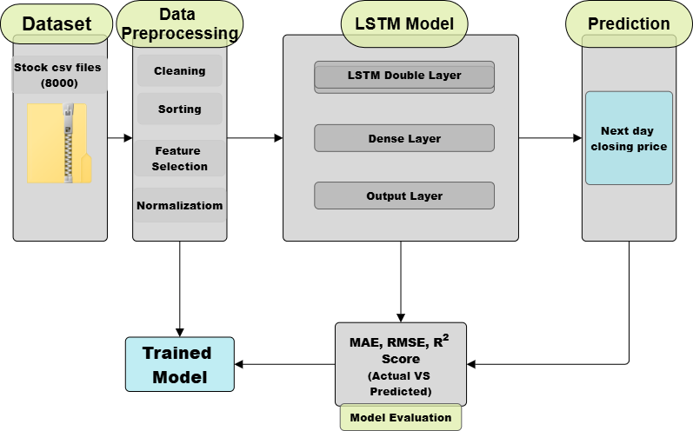

Figure 1: Model Diagram

Experiment:
We have conducted an experiment on Sequence Length. Multiple experiments were conducted using different sequence length, to evaluate the effect of historical time window size on stock price predictions. The LSTM model was trained separately using 30-day, 60-day, and 90-day.

Here sequence length is the chosen parameter. By changing this parameter for different Stocks every time we got different values of accuracy, predicted next day price, and forecasted next day price. By comparing these parameters, which sequence length would be the best for the Model could be identified.

Here is a table showing the results after conducting the experiment:
Stock Name: LD
 | Accuracy | Predicted next day price | Forecasted next day price
30 Days | 96.47% | 35.89 | 39.18
60 Days | 96.52% | 35.7 | 38.42
90 Days | 96.1% | 36.42 | 40.2
Table:1

Stock Name: BNO
 | Accuracy | Predicted next day price | Forecasted next day price
30 Days | 81.94% | 9.34 | 9.86
60 Days | 88.27% | 8.33 | 8.84
90 Days | 83.98% | 8.99 | 9.49
Table:2

Stock Name: AAMC
 | Accuracy | Predicted next day price | Forecasted next day price
30 Days | 93.89% | 11.87 | 16.46
60 Days | 96.63% | 11.04 | 14.48
90 Days | 95.83% | 11.92 | 15.39
Table:3

Three Stocks (LD, BNO, AAMC) were chosen from the 8000 stocks and conducted experiment on them.

Result and alalysis
The results were analyzed using both numerical evaluation metrics and visual comparison between actual and predicted prices.

Evaluation Metrics:

Mean Absolute Error (MAE):
MAE value shows the average difference between actual and predicted value. A lower MAE means that the model made smaller prediction errors.

Root Mean Square Error (RMSE):
RMSE helps to identify if the model made any major wrong predictions by giving more weight to larger errors.

R² Score:
The R² score shows how well the model followed the actual value. A higher R² score indicates better prediction performance.

Stock Name: LD
 | MAE | RMSE | R²
30-days | 0.5031 | 1.0962 | 0.9647
60-days | 0.4887 | 1.1081 | 0.9652
90-days | 0.6025 | 1.1147 | 0.9610
Table: 4

Stock Name: BNO
 | MAE | RMSE | R²
30-days | 0.8167 | 1.0955 | 0.8194
60-days | 0.6772 | 0.8864 | 0.8827
90-days | 0.7727 | 1.0398 | 0.8398
Table: 5

Stock Name: AAMC
 | MAE | RMSE | R²
30-days | 0.5901 | 1.0705 | 0.9389
60-days | 0.5731 | 1.0487 | 0.9663
90-days | 0.6123 | 1.2270 | 0.9583
Table: 6

As shown in Tables 4- 6, the values of MAE, RMSE and R2 are better for 60 days rather than 30-days or 90-days for these 3 stock prices.

Visual Comparison:

Historical Data:

For each stock price a line graph can be generated for proper visualization of how the stock price was up till now. Here are three-line graphs for LD, BNO, and AAMC.

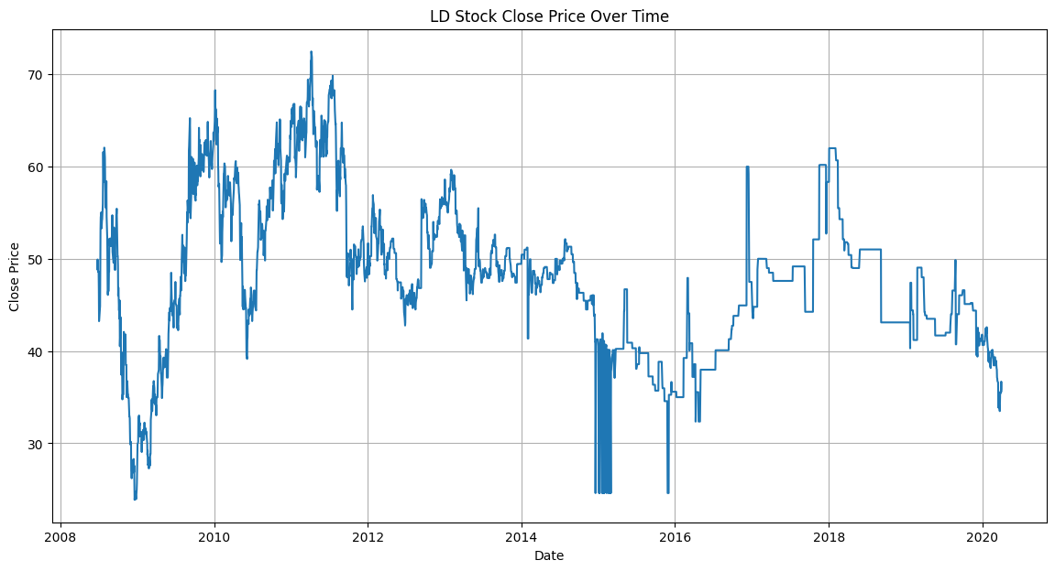
Figure 2: LD Stock Close Price Over Time

This graph shows that; the stock price of LD is very much unstable. There is a huge change in price in a short time period.

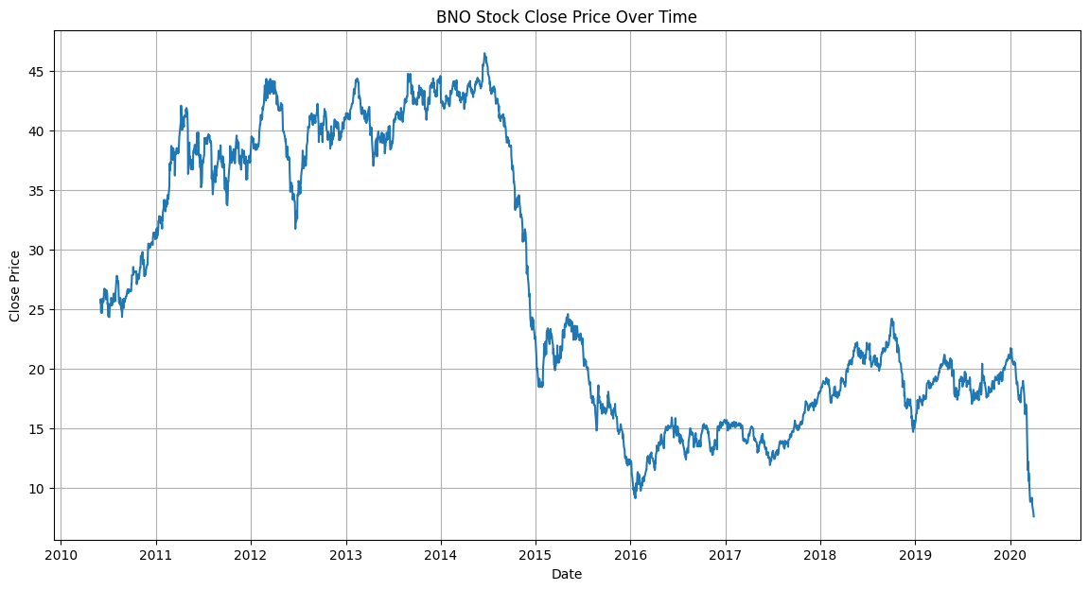
Figure 3: BNO Stock Close Price Over Time

This graph shows that the stock price of BNO was very high and also a little bit unstable. But after a time period it dropped and fluctuated between 10 to 20.

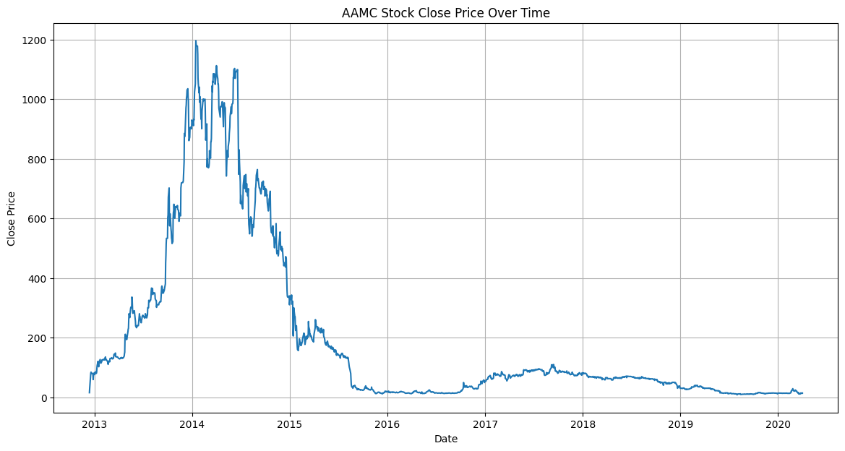
Figure 4: AAMC Stock Close Price Over Time

This graph shows that the stock price of AAMC started with low price but the price began increasing within a short period and also dropped near to zero within 2 years. After that the price increased and remained stable around 50 to 100.

Actual vs Predicted Price Analysis:

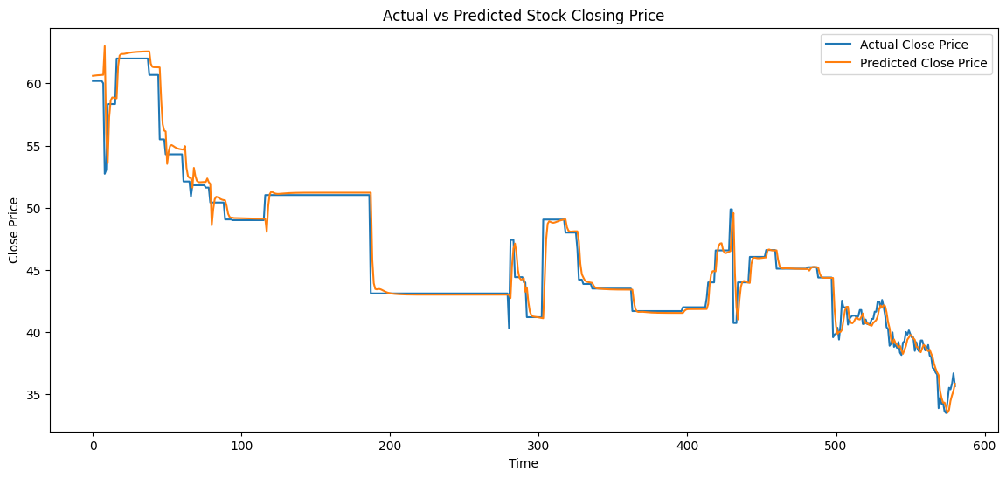

Figure 5: LD Actual vs Predicted Stock Closing Price

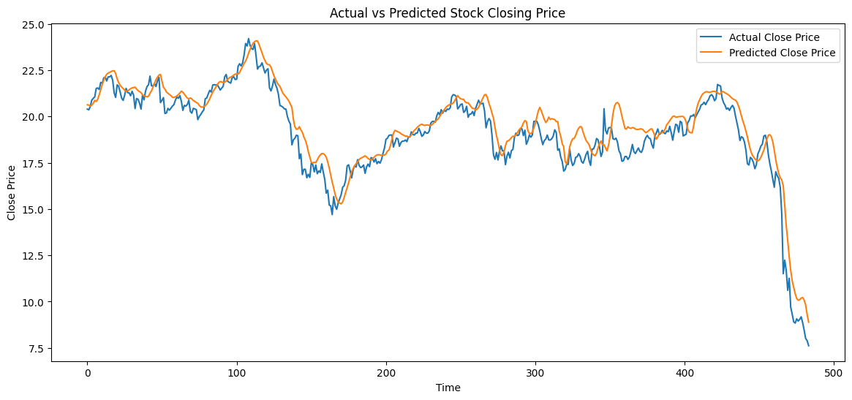

Figure 6: BNO Actual vs Predicted Stock Closing Price

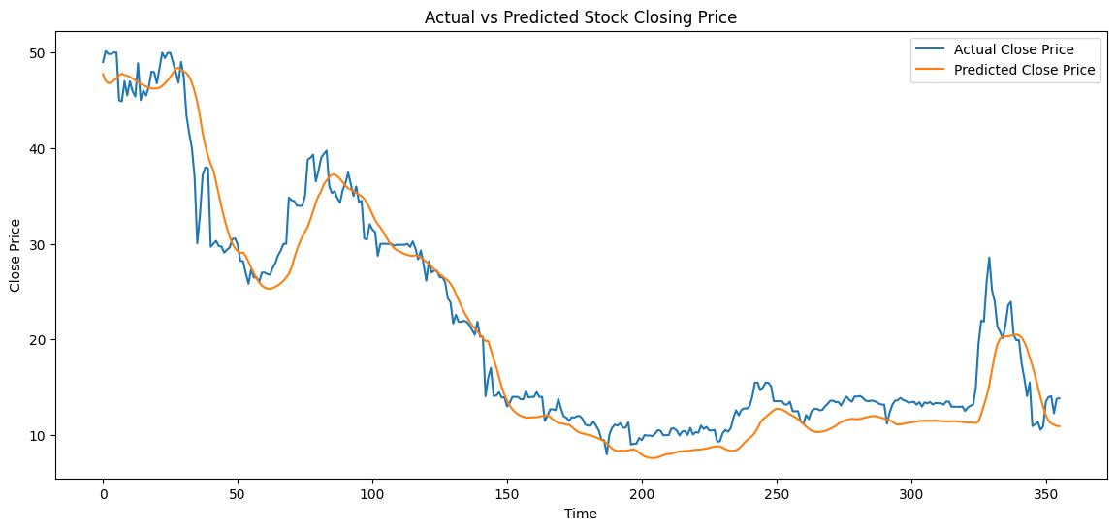

Figure 7: AAMC Actual vs Predicted Stock Closing Price

These graphs show that the LSTM model was able to move closely with the actual price line, which indicates that the model was able to learn time series data almost perfectly. But sudden changes in price were difficult to observe.

Training and Validation Loss Analysis:

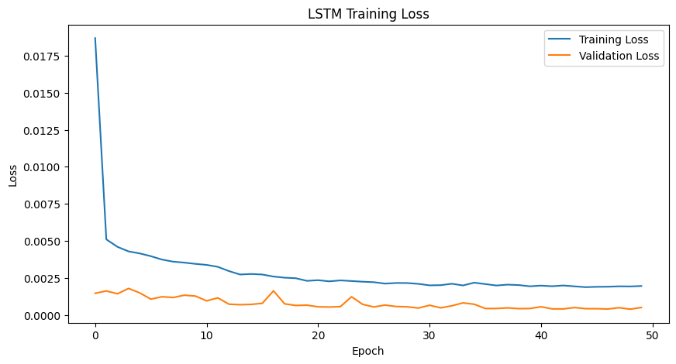

Figure 8: LD Training and Validation Loss

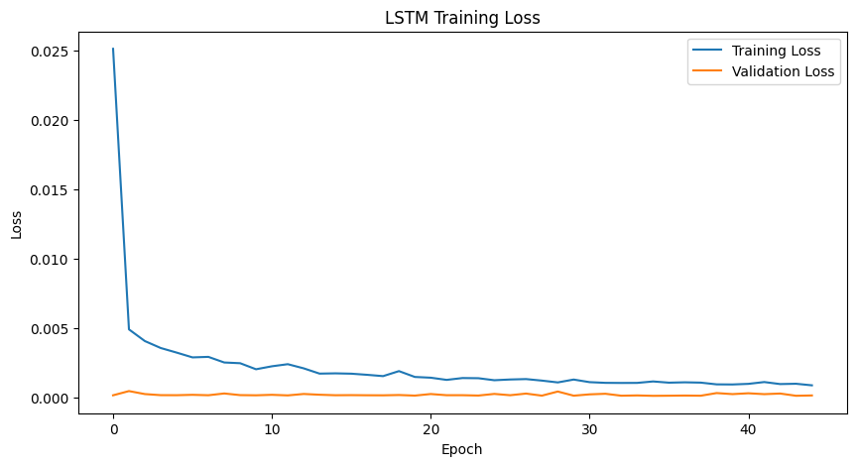
Figure 9: BNO Training and Validation Loss

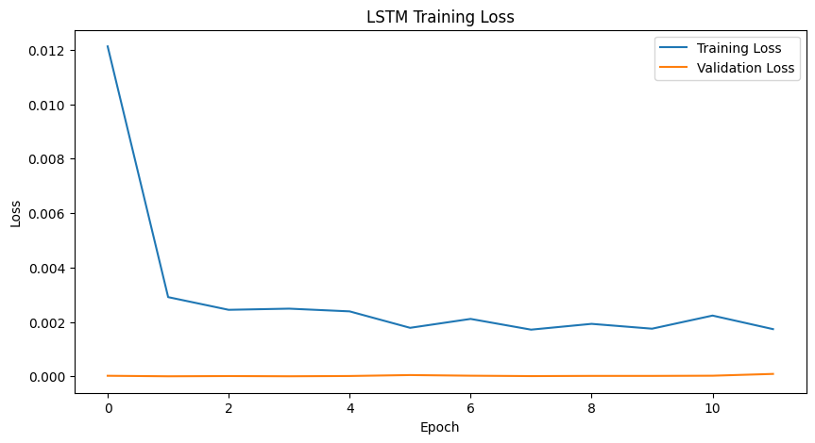
Figure 10: AAMC Training and Validation Loss

These graphs show the learning behavior of the model. During training the loss gradually decreased, and it means that the model was learning from the data. It also shows that the validation loss also decreased overtime and remained close to training loss. There was a possibility that the validation loss could increase and training loss decreased, it would indicate overfitting. To reduce overfitting dropout layers were used in LSTM architecture.

Discussion & Conclusion:
This proposed model was designed to learn sequential patterns from historical stock prices and forecast nest day closing stock price.

The experiments showed that sequence length had a significant effect on prediction performance. For most of the dataset including LD, BNO, AAMC the 60-days sequence produced batter results. It also achieved lower MAE and RMSE values and higher R² score compared to 30-day and 90-day model.

From the visual comparison graphs, between actual and predicted prices shows that the model was able to follow movement of stock price closely. The training and validation loss graphs demonstrated the model learned effectively without significant overfitting.

Limitations:
Although achieving promising result, there are some limitations remain in this study.
- This model relied only on historical data and did not include external factors like economic news, investor behavior, company performance, and market sentiment
- This model includes only one feature as target. (closing price)

Future Work:
For future work many improvements can be introduced to enhance prediction performance:
- Comparing LSTM with GRU transformer, and hybrid deep learning model.
- Developing real-time stock market prediction web application.
- Applying sentiment analysis using financial news and social media data.
- Applying hyperparameter optimization techniques for batter accuracy.

In conclusion, the comparative experimental results show that the LSTM model was effective enough to capture time-series dependencies and predict accurate stock price. Although stock market prediction remains challenging due to market uncertainty, This research confirms that LSTM is a powerful and effective deep learning approach for stock price forecasting.

References:
- P. Chhajer, M. Shah, and A. Kshirsagar, “The applications of artificial neural networks, support vector machines, and long–short term memory for stock market prediction,” Decision Analytics Journal, vol. 2, p. 100015, 2022.
- A. Moghar and M. Hamiche, “Stock market prediction using LSTM recurrent neural network,” Procedia Computer Science, vol. 170, pp. 1168–1173, 2020.
- S. Ouf, M. El Hawary, A. Aboutabl, and S. Adel, “A deep learning-based LSTM for stock price prediction using Twitter sentiment analysis,” International Journal of Advanced Computer Science and Applications, vol. 15, no. 12, 2024.
- M. S. Zakka and Emigawaty, “Stock price prediction using deep learning (LSTM) with a recursive approach,” Journal of Applied Informatics and Computing, vol. 9, no. 5, pp. 2468–2477, 2025.
- C. R. Ko and H. T. Chang, “LSTM-based sentiment analysis for stock price forecast,” PeerJ Computer Science, 2021.
- S. Sang and L. Li, “A novel variant of LSTM stock prediction method incorporating attention mechanism,” Mathematics, vol. 12, no. 945, 2024.
- B. I. Maikatsina, E. S. Chaku, and M. I. Umar, “Comparative analysis of machine learning algorithms for stock price prediction,” Journal of Basics and Applied Sciences Research, vol. 3, no. 6, pp. 243–251, 2025.
- B. Gautam, S. Kandel, M. Shrestha, and S. Thakur, “Comparative analysis of machine learning models for stock price prediction: Leveraging LSTM for real-time forecasting,” Journal of Computer and Communications, vol. 12, pp. 52–80, 2024.
- J. Xiao, T. Deng, and S. Bi, “Comparative analysis of LSTM, GRU and transformer models for stock price prediction,” in Proc. Int. Conf. Digital Economy, Blockchain and Artificial Intelligence (DEBAI), Guangzhou, China, 2024, pp. 103–108.
- P. Sidhu, H. Aggarwal, and M. Lal, “Stock market prediction using LSTM,” in Proc. Int. Conf. Intelligent Computing and Data Science Systems, New Delhi, India, 2020.
- H. Li, Y. Shen, and Y. Zhu, “Stock price prediction using attention-based multi-input LSTM,” in Proc. Asian Conf. Machine Learning (ACML), 2018, pp. 454–469.
- M. K. Bhatia and V. Bhatt, “Forecasting time series data using recurrent neural networks: A systematic review,” Journal for Research in Applied Sciences and Biotechnology, vol. 3, no. 6, pp. 184–189, 2024.
- A. Ghosh, S. Bose, G. Maji, N. C. Debnath, and S. Sen, “Stock price prediction using LSTM on Indian share market,” in Proc. Int. Conf. Computer Applications in Industry and Engineering (CAINE), 2019, pp. 101–110.
- P. B. S. Pramod and M. S. P. M., “Stock price prediction using LSTM,” Journal Publication, vol. 83, pp. 5246–5251, 2020.
- S. Mehtab, J. Sen, and A. Dutta, “Stock price prediction using machine learning and LSTM-based deep learning models,” in Proc. Data Science and Artificial Intelligence Research Publication, 2020.

